**Alan Wake 2 Glitch Report**

**Created By**

**Nimeshkumar Chaudhari**

**1. Game Title and Version:**

* Game Title: Alan Wake 2
* Version: 1.0.14.1

**2. Platform**:

* Platform: PC
* Operating System: Windows

**3. Description of the Glitch:**

* This glitch occurs in chapter Return 6: Scratch Saga takes a new shotgun and tries to head down while the flashlight is active. While opening a door during animation, the flashlight is stacked in the air while she opens a door.

**4. Steps to Reproduce:**

* It will occur when You can head down from the lower floor and turn your torch on.

**5. Expected Behavior:**

* The torch should not levitate in thin air. It should be attached to the handheld, or Saga should temporarily put the torch back.

**6. Screenshots & Video**

* Screenshots

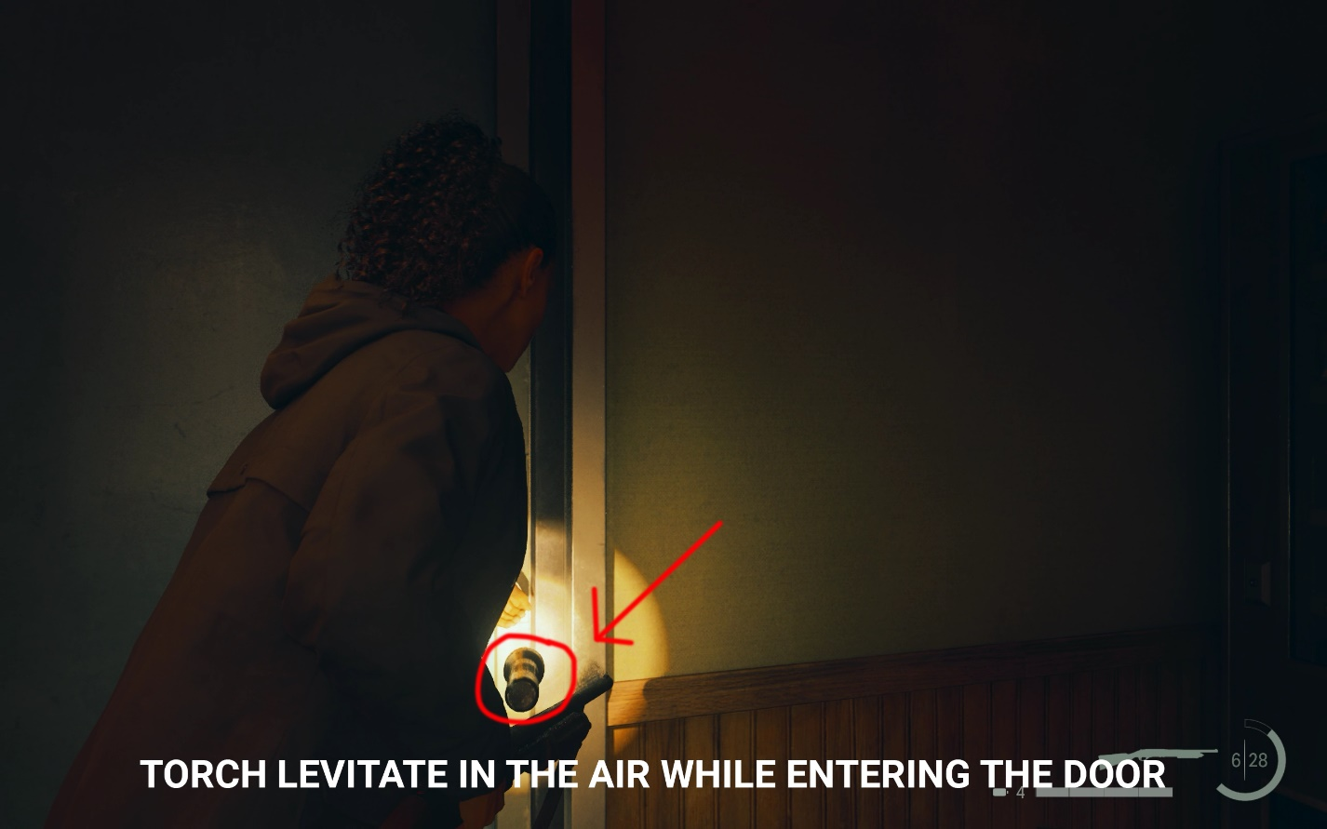

* Video Link:

https://youtu.be/wmaZ3dKIVAg

**7. System Information:**

* Operating System: Windows 11
* Processor: 13th Gen Intel® Core™ i9-13900HX (36 MB cache, 24 cores, 32 threads, up to 5.40 GHz Turbo)
* RAM: 32 GB: 2 x 16 GB, DDR5, 4800 MT/s
* Graphics Card: NVIDIA® GeForce RTX™ 4070, 8 GB GDDR6
* Product Link: www.dell.com/en-ca/shop/gaming-laptops/g16-gaming-laptop/spd/g-series-16-7630-laptop/caeghbts7630glrf

**8. Frequency of the Issue:**

* This glitch occurs as often as you meet the condition to keep the torch active and going through the door.

**8. All Resources:**

* https://github.com/Nimesh2099/Glitch-Reports